We have implemented the table pokemon and the database is loaded in the created table to get required queries to be executed.

Here in all the questions we are supposed to get the average of some columns so we use the keyword avg(column_name).

1. Find out the average HP (Hit points) of all the Pokémons

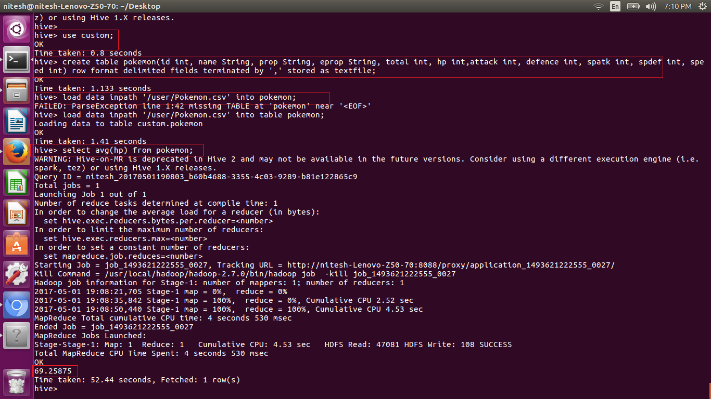

2. Find out the average Defense of all the pokemon

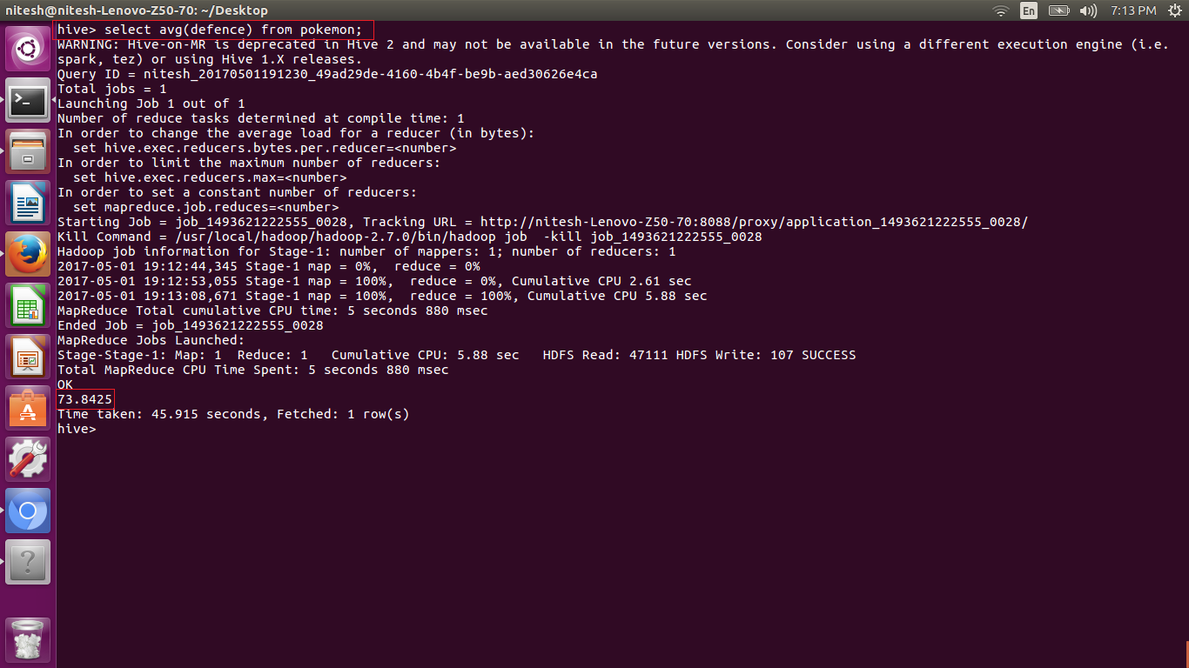

3. Find out the average Sp.Atk of all the pokemons

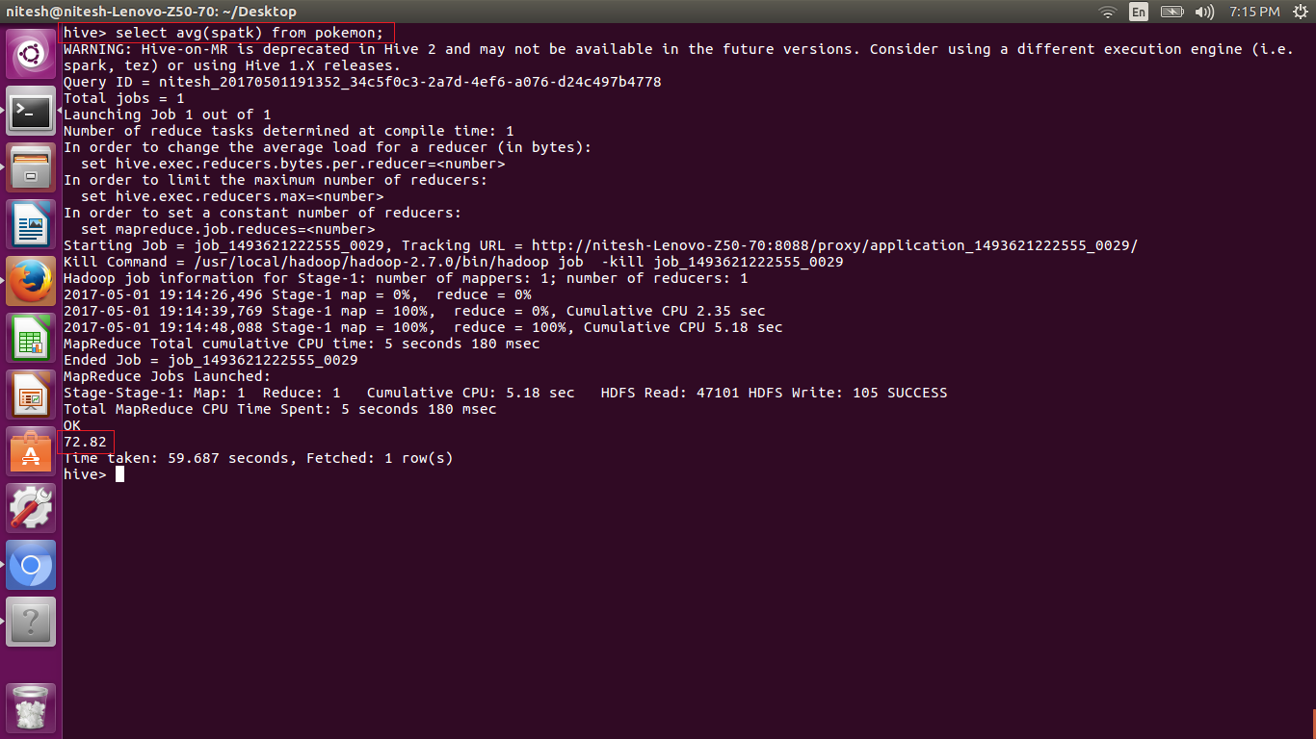

4. Find out the average sp.Def of all the pokemons

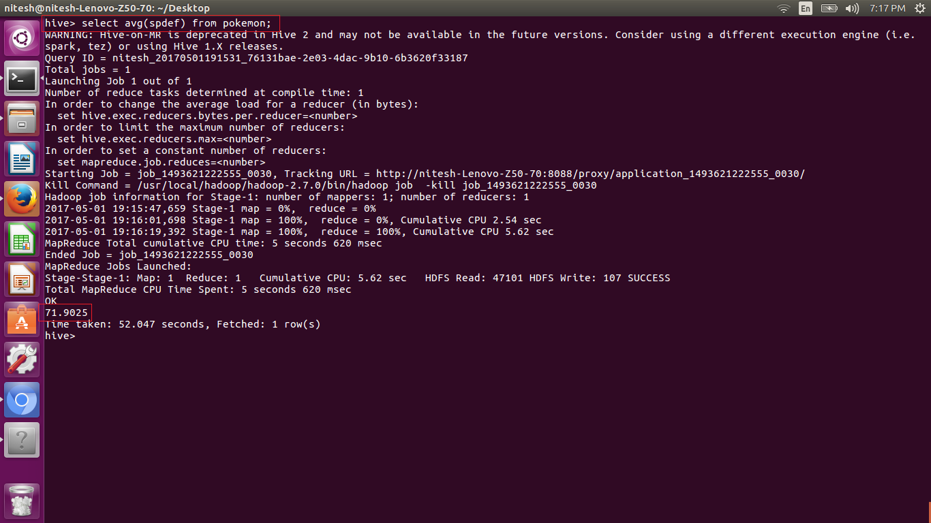

5. Find out the average Speed of all the pokemons

